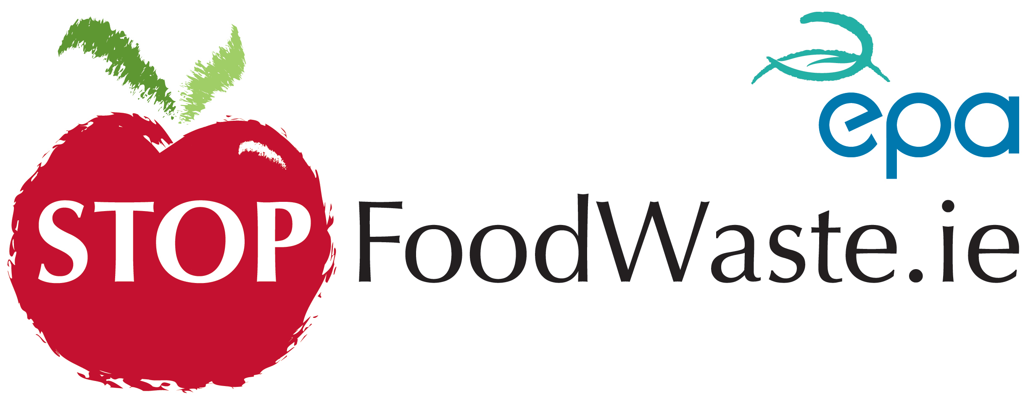
Media Release
28th May 2014
Stop Food Waste and the Local Authority Prevention Network at the
“Food for Thought” Garden at Bloom

Stop Food Waste welcomes EU proposals to scrap compulsory “best before” labels
Speaking at the unveiling of Dublin City Council’s “Food for Thought” garden at Bloom, the EPA’s Stop Food Waste programme today welcomed EU proposals to scrap compulsory “best before” labels on certain products to help reduce the estimated 100 million tonnes of food wasted across Europe each year. In the meantime Stop Food Waste along with the Local Authority Prevention Network in Ireland are forging ahead with their plans for the fight against food waste from the second half of 2014 and are launching their campaign at Bloom with the “Food for Thought” Garden.
“It is fitting that this EU move comes as we prepare to launch the next phase in Ireland’s response to food waste,” said Odile Le Bolloch, spokesperson for the Stop Food Waste programme at the EPA. “We warmly welcome the EU’s move to extend the list of foods that do not require best before dates; we’ve always been supporters of the premise that best before doesn’t mean bad after and in the case of certain foods this can mean a considerably long time after once the foods are stored correctly”.
The main aim of the ‘Food for Thought’ Garden at Bloom, designed by Elma Fenton and commissioned by Dublin City Council and Cork Institute of Technology’s Clean Technology Centre, is to highlight food waste and show how to prevent it. The ‘Food for Thought’ Garden is supported by the Stop Food Waste programme and the Local Authority Prevention Network. These initiatives work in partnership with local community groups, businesses, festivals and householders to promote and highlight the message of food waste prevention nationwide.

In Ireland there is over one million tonnes of food waste disposed of each year and around 1/3 of this waste comes from households. This means that each household is throwing out about 1/4 of a tonne of food waste each year, costing the average household €700.

Co-ordinated by the EPA, the Local Authority Prevention Network draws together local authority personnel undertaking activities on waste prevention and resource efficiency at a local level. In particular the Network is actively working with festivals around the country. As part of this work, Dublin City Council has been involved at Bloom, reducing the amount of waste going to landfill by, in the first instance, introducing a new 3-bin system (separating waste into food waste, recyclables and mixed wastes). There will be volunteers at the different bin stations giving information about these environmental initiatives. “festivals and events attract a huge number of visitors and local authorities in the prevention network are ensuring that such events are more sustainable and are assisting festival and event organisers in achieving this”, said Sandra Smith Environmental Awareness Officer, Dublin City Council.

Speaking at the event today, Gary Graham, Bloom Show Manager, Bord Bia, welcomed the new partnership with Dublin City Council. “In keeping with the overall ethos of Bloom, each year we aim to improve on our sustainability and recycling initiatives. We are very excited about our plans to further build on this objective in the years ahead”, he said.

During 2014 the Local Authority Prevention Network and Stop Food Waste will work even more closely to highlight the significant amount of work being done on food waste in Ireland. Keep an eye on www.localprevention.ie for many of the different events that the Network will be working on throughout the country this summer, and for local Stop Food Waste Challenge events which will launch nationally in the Autumn.
(Ends)
For further information or to reserve a place, request an interview or photography contact the Stop Food Waste Press Office at H+K Strategies PR
Maeve Governey - 086 805 7884 Email: maeve.governey@hkstrategies.ie or Naomi Keating on 01 669 0030
Note for Editors:
EU legislation on food labelling currently requires all food to carry a ‘use by date’ for highly perishable goods, such as raw meat and dairy produce, that may pose a danger to human health if eaten after this date, or a ‘best before date’ for foods that have a long shelf life, like dried and tinned goods. Consumers often throw food away unnecessarily because of confusion about the meaning of the 'best before' date. Products usually remain edible beyond this date, but are nonetheless thrown away. According to EU officials, consideration is being given to extending the list of products which could be exempted from the requirement to have a ‘best before’ date on labels, based on the premise that consumers can tell for themselves when food has gone off and that minor changes in appearance should not lead to foodstuffs being thrown away. According to the World Bank, about 35% of food ends up being thrown away, most of it dumped by consumers in the developed countries and studies have shown that approximately 15 per cent of food waste is caused by expiry dates on packaging.
Stop Food Waste guide to understanding dates:
Use-by’ date – A Deadline
This is a key date for food safety – food should be eaten by this date. ‘Use by’ appears on fresh food that goes off such as fish, meat, salads and dairy products. Food should not be used past this date unless it has been frozen.
‘Best-before’ date – A Guideline
This appears on a wide range of longer lasting foods such as tinned, dried and frozen foods. Food is in its best condition up to this date. Food is safe to eat after this date, but it may begin to lose its flavour and texture. This is therefore a general rule of thumb.
Sell by and Display until dates….
These are used by shops for stock control and can be ignored by householders. Food is often perfect to eat for a number of days after this date and these dates contribute to a huge amount of waste of good food in the retail trade each year.

