Local Authority Prevention Network  Plenary Meeting  Buswells Hotel Dublin  Wed 20 & Thurs 21 February 2013 | 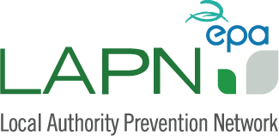

Agenda
Wed 20 February:
Topic: | Workshop
15:00 – 17:30 | Social media marketing workshop | TBC

19:30 Dinner in Buswells Hotel bar (at delegates own expense)

Thurs 21 February:
09:45 – 10:00 | Welcome and introduction | EPA
10:00 – 10:15 | LAPN technical support update for 2013 | Clean Technology Centre
10:15 – 10:30 | Green Fleadh video
10:30 – 11:00 | Tea/coffee
11:00 – 12:00 | Review of 2012 and ambitions for 2013:  A chance for the group to discuss highlights from 2012 and plans for 2013. For new attendees or those who are planning on starting some waste prevention work, a chance to talk about how to approach this and what they’d like to gain from the Network. | All- ‘Tour de table’
12:00 – 12:30 | Kilbarrack Fire Station Green Plan | ACFO Richard Hedderman
12:30 – 13:30 | Lunch
13:30 – 14:30 | GAA pitches in Mayo & Longford | Sharon Cameron,  Mayo Co. Co.
 | Water Conservation project in Bandon | Cork Co. Co.

